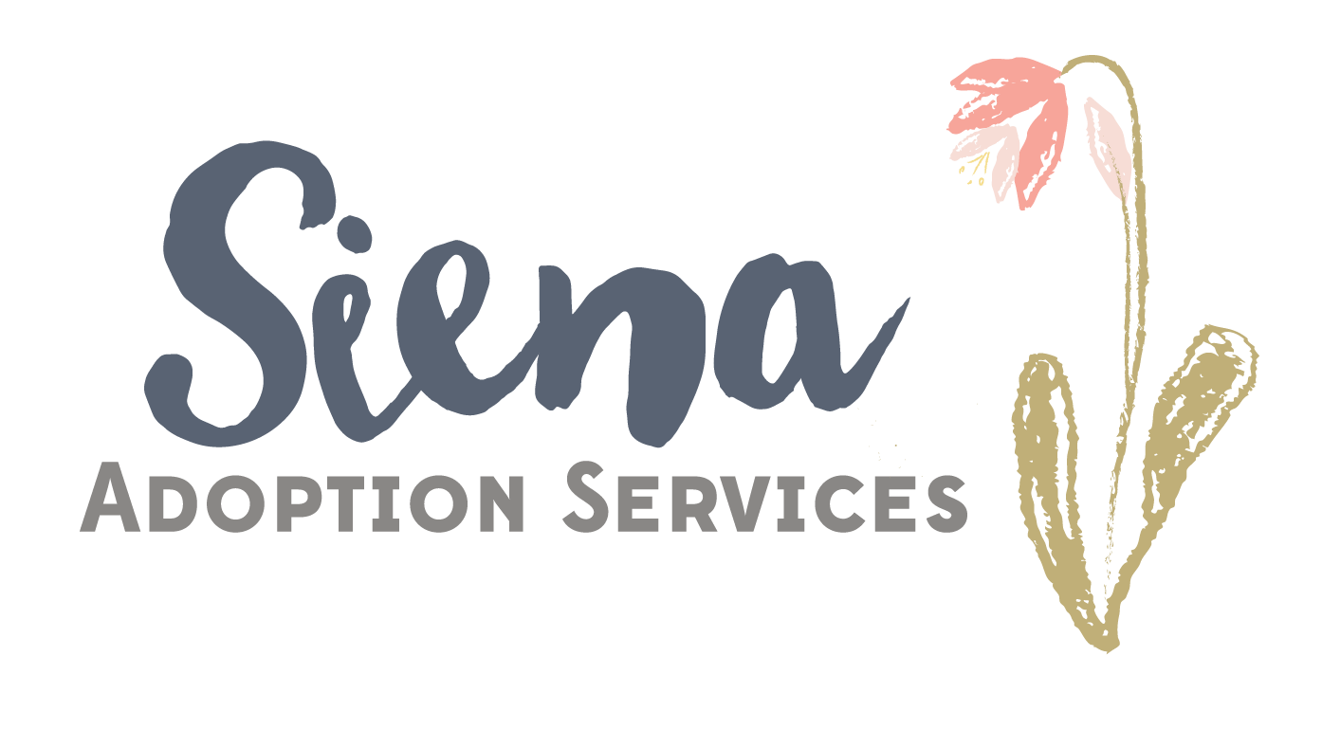
Siena Adoption Services
2776 S. Arlington Mill Dr. Suite #524
Arlington, VA 22206
(703) 477-0411
sienaadoptionservices@gmail.com

Services and Fees

Application fee, including intake call: $200
Due when submitted
Domestic Adoption Home Study: $1500
*Includes three in-person visits, a home inspection, collection and review of required documentation, and preparation of a notarized home study report along with a complete home study packet in accordance with Virginia state requirements
$750 at first visit, $750 upon completion
Expedited Adoption Home Study: $1800
International Adoption Home Study: $2000
$1000 at first visit, $1000 upon completion
Agency Consultant and Professional Fees: $3000-$5000
Due at Placement
(only applicable if Siena is placing agency)
Post Placement per visit: $250
Due at visit
Home Study Update: $500
Due at visit
Update-(when original study is from another agency) $650

Home Study Court Report $250

Travel (in excess of 30 miles): $0.58
Due at visit
*All fees are non-refundable

________________________________________________________________________________
Applicant’s Signature Date

